
CSE422: Artificial Intelligence
A
Summer 2025
Theory QUIZ-01
Duration: 30 Minutes

Name: | ID: | Section:
1)a. Comment on the admissibility of heuristic and fix any values on the table if needed. (4)
b. Now perform A* search using the edited/updated heuristic values if any. (6)
c. Now comment on the heuristic consistency of the nodes S and F. Must show calculation to justify your answer. (4)
d. Using the updated heuristic table, can we perform a A* Search to find optimal path from state S to node E? Please provide a brief explanation for your answer (2)
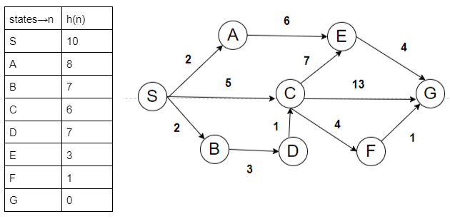

2)Suppose you have three heuristic functions h1, h2 and h3. Among these h1 and h2 are
admissible but h3 is inadmissible. You have decided to create several new heuristic
functions defined as follows:
● h4(n) = 0
● h5(n) = 2 × h2(n)
● h6(n) = (h1(n)+h2(n))/2
● h7(n) = max(h1(n), h2(n))
● h8(n) = min(h1(n), h3(n))
● h9(n) = max(h2(n), h3(n))
Now answer the following questions and justify. [4]
i. Which two heuristics are possibly inadmissible?
ii. Among h6 and h7 which one is dominant?
iii. In your opinion which heuristic is the best?

CSE422: Artificial Intelligence
B
Summer 2025
Theory QUIZ-01
Duration: 30 Minutes

Name: | ID: | Section:
1)a. Comment on the admissibility of heuristic and fix any values on the table if needed. (4)
b. Now perform A* search on the edited heuristic values if any. (6)
c. Now comment on the heuristic consistency of the nodes S and F. Must show calculation to justify your answer. (4)
d. Using the updated heuristic table, can we perform a A* Search to find optimal path from state S to node F? Please provide a brief explanation for your answer (4)

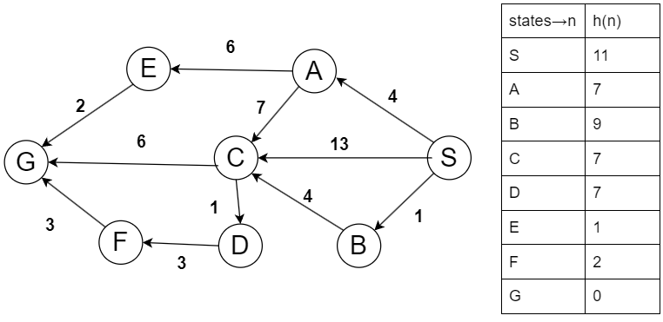

2)Suppose you have three heuristic functions h1, h2 and h3. Among these h1 and h2 are
admissible but h3 is inadmissible. You have decided to create several new heuristic
functions defined as follows:
● h4(n) = 0
● h5(n) = 2 × h2(n)
● h6(n) = (h1(n)+h2(n))/2
● h7(n) = min(h1(n), h2(n))
● h8(n) = max(h1(n), h3(n))
● h9(n) = min(h2(n), h3(n))

Now answer the following questions and justify. [4]
i. Which two heuristics are possibly inadmissible?
ii. Among h6 and h7 which one is dominant?
iii. In your opinion which heuristic is the best?

